EXPERIMENT 6

Write the Queries for the following using In-built functions.

1. Retrieve average salary of all employees.

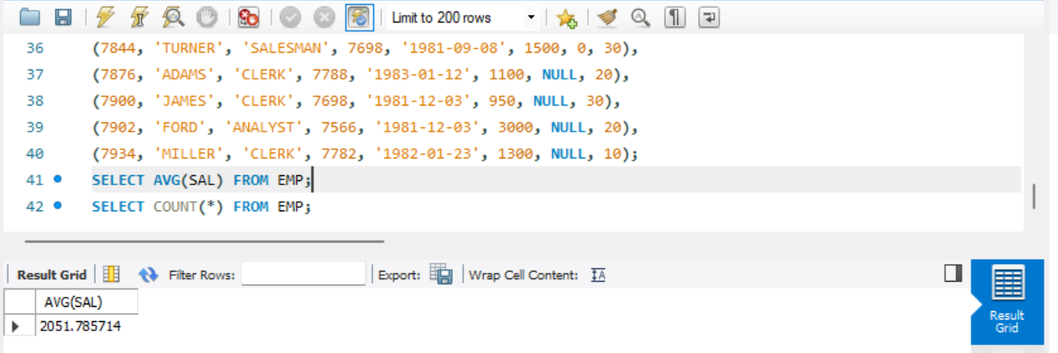

1. Retrieve the number of employees.

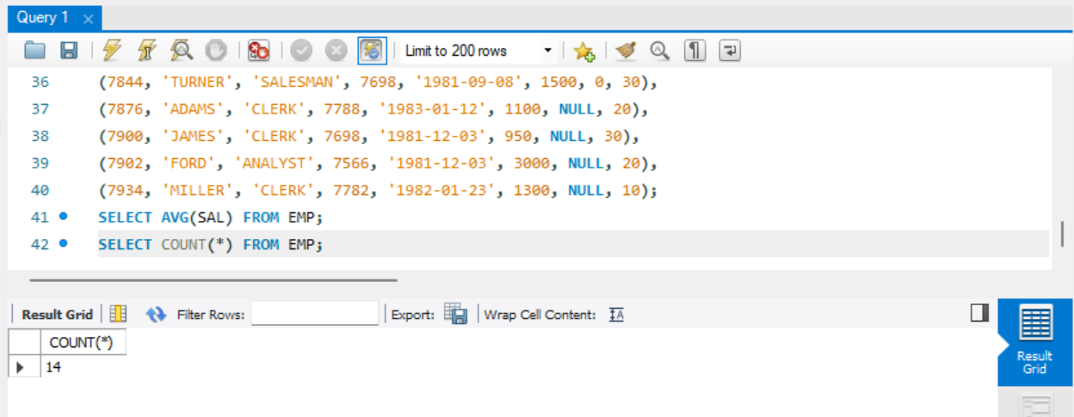

1. Retrieve distinct number of employee.

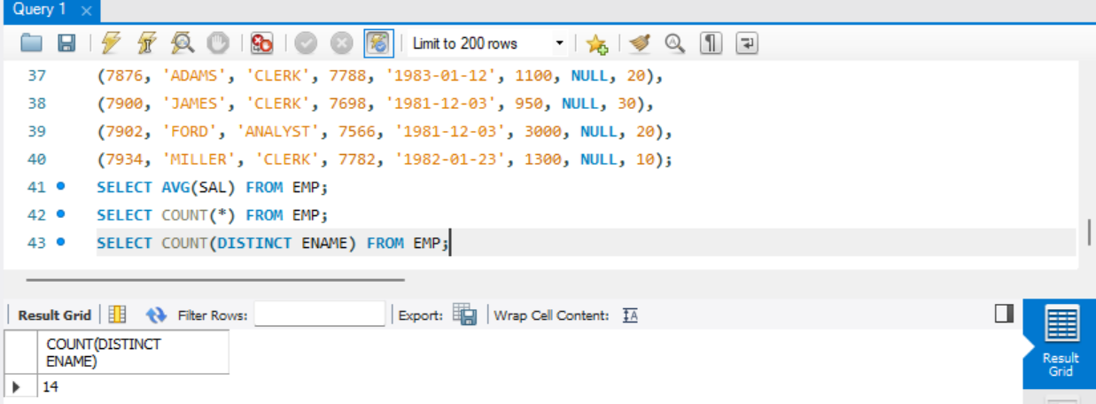

1. Retrieve total salary of employee group by job.

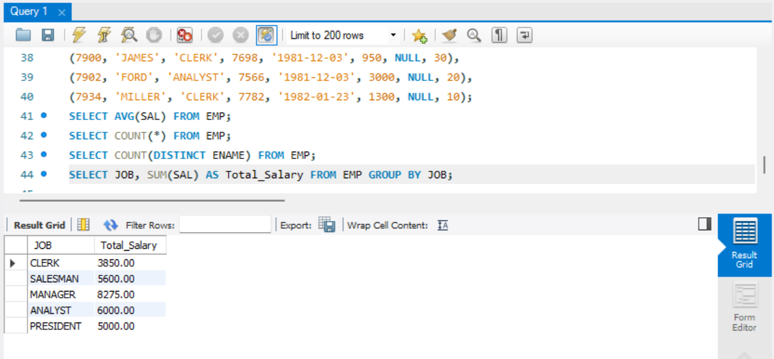

1. Display the employee information with maximum salary.

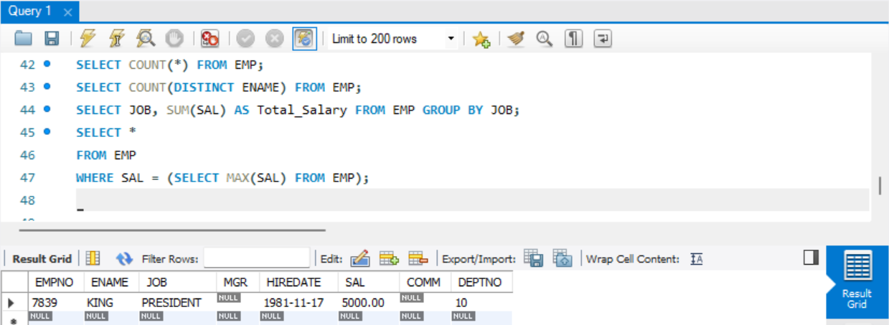

1. Find the highest paid employee in department 10.

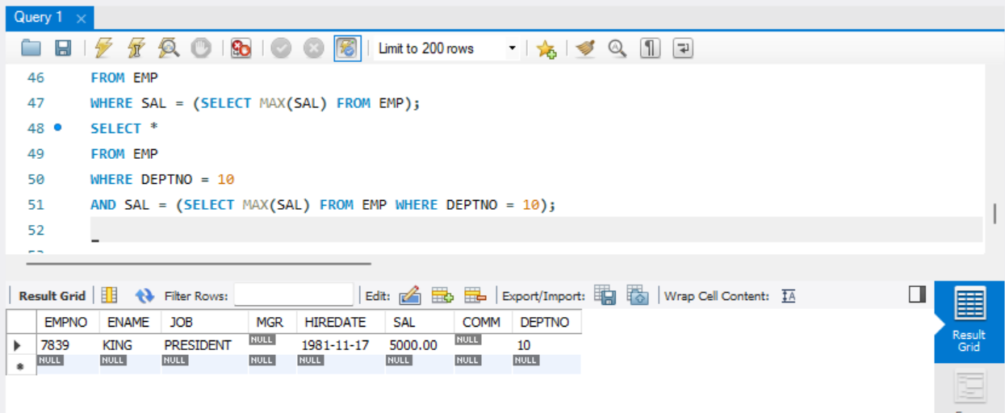

1. List the emps whose sal is equal to the average of max and minimum.

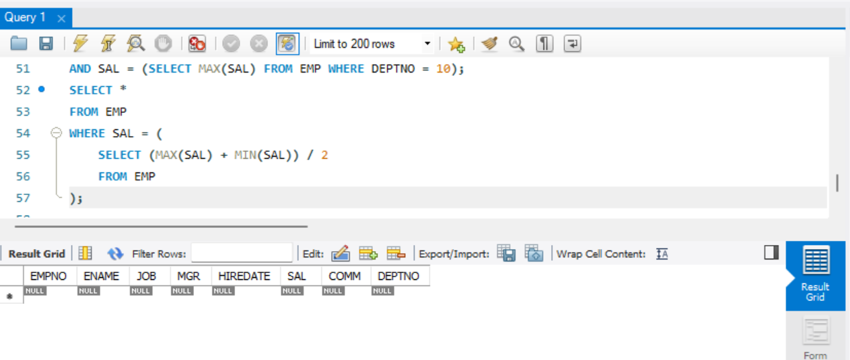

1. List the emps who joined in the company on the same date.

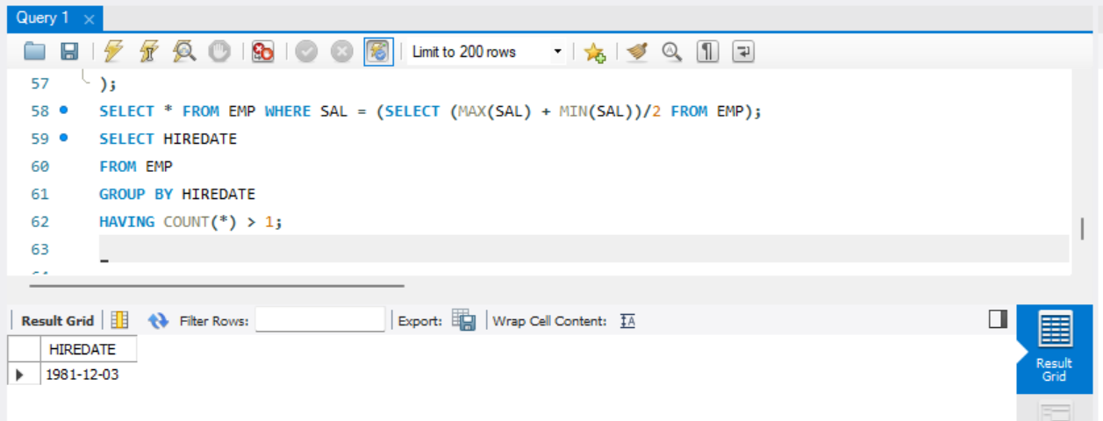

1. Display the employee names in upper and lower case.

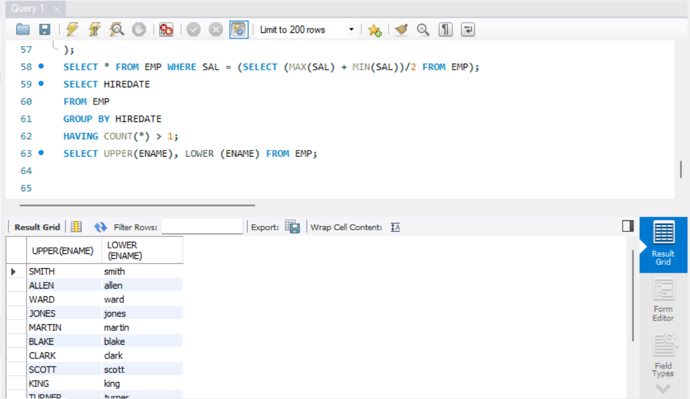

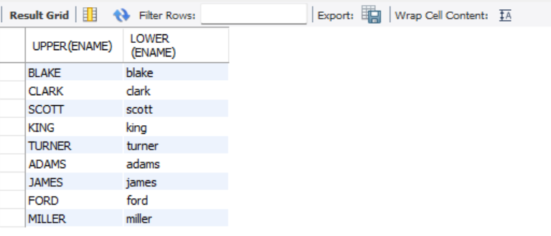

1. find the date of 3 days later from hiredate.

